# PERSONAL EXPENSE TRACKER APPLICATION

**IBM-Project-16212-1659609643**

**NALAIYA THIRAN PROJECT BASED LEARNING ON PROFESSIONAL READLINESS FOR INNOVATION, EMPLOYNMENT AND ENTERPRENEURSHI**

### PROJECT REPORT BY

**TEAM ID : PNT2022TMID11924**

|  |  |  |
| --- | --- | --- |
|  | **Name** | **Roll No** |
| Team Leader | SUNDARESAN N | 1921201 |
| Team Member | DINESH KUMAR M | 1921123 |
| Team Member | GOKULRAJ R | 1921128 |
| Team Member | ASHWIN S | 1921111 |

BACHELOR OF TECHNOLOGY IN INFORMATION TECHNOLOGY

K S RANGASAMY COLLEGE OF TECHNOLOGY

(Autonomous Institution)

Tiruchengode - 637215

**INDEX**

### INTRODUCTION

* 1. Project Overview
  2. Purpose

### LITERATURE SURVEY

* 1. Existing problem
  2. References
  3. Problem Statement Deﬁnition

### IDEATION & PROPOSED SOLUTION

* 1. Empathy Map Canvas
  2. Ideation & Brainstorming
  3. Proposed Solution
  4. Problem Solution ﬁt

### REQUIREMENT ANALYSIS

* 1. Functional requirement
  2. Non-Functional requirements

### PROJECT DESIGN

* 1. Data Flow Diagrams
  2. Solution & Technical Architecture
  3. User Stories

### PROJECT PLANNING & SCHEDULING

* 1. Sprint Planning & Estimation
  2. Sprint Delivery Schedule
  3. Reports from JIRA

### CODING & SOLUTIONING (Explain the features added in the project along with code)

* 1. Feature 1
  2. Feature 2
  3. Database Schema (if Applicable)

### TESTING

* 1. Test Cases
  2. User Acceptance Testing

### RESULTS

Performance Metrics

### ADVANTAGES & DISADVANTAGES

1. **CONCLUSION**

### FUTURE SCOPE

1. **APPENDIX**

Source Code GitHub Link

# INTRODUCTION

## PROJECT OVERVIEW

Category: Cloud App Development Team ID : PNT2022TMID35494

## SKILLS REQUIRED:

IBM Cloud,HTML,Javascript,IBM Cloud Object Storage,Python- Flask,Kubernetes,Docker,IBM DB2,IBM Container

## PROJECT DESCRIPTION :

In simple words, personal ﬁnance entails all the ﬁnancial decisions and activities that a Finance app makes your life easier by helping you to manage your ﬁnances eﬃciently. A personal ﬁnance app will not only help you with budgeting and accounting but also give you helpful insights about money management.

Personal ﬁnance applications will ask users to add their expenses and based on their expenses wallet balance will be updated which will be visible to the user. Also, users can get an analysis of their expenditure in graphical forms. They have an option to set a limit for the amount to be use for that particular month if the limit is exceeded the user will be notiﬁed with an email alert.

## PURPOSE

Personal expense management plays a very important role. Without an expense tracker

,one may miss out the ability to manage the ﬁnances wisely and effortlessly. So the expenses may go through the roof. With a help of a proper expense tracker, one becmes aware of how ,when and why the amount is being is spent.So, an expense tracker is a software or application that helps to keep an accurate record of your money inﬂow and outﬂow. Many people in India live on a ﬁxed income, and they ﬁnd that towardsthe end of the month they don’t have suﬃcient money to meet their needs. While this problem can arise due to low salary, invariably it is due to poor money management skills. Using a daily expense manager can help you keep track of how much you spend every day and on what. At the end of the month, you will have a clear picture where your money is going. This is one of the best ways to get your expenses under control and bring some semblance of order to your ﬁnances.Today, there are several expense manager applications in the market. Before you decide to go in for a money manager, it is important to decide the type you want.

# LITERATURE SURVEY

## EXISTING PROBLEM:

In a study conducted by Forrester in 2016 surveying small and medium businesses(SMBs) across the world, 56% companies reported expense management as being the biggest challenge for their ﬁnance departments. In another survey conducted by Levvel Research in 2018 in North America, respondents reported the following pain pointsin expense management before adopting automation:

* + - Manual entry and routing of expense reports (62%)
    - Lack of visibility into spend data (42%)
    - Inability to enforce travel policies (29%)
    - Lost expense reports (24%)
    - Lengthy expense approval system and reimbursement

## REFERENCES:

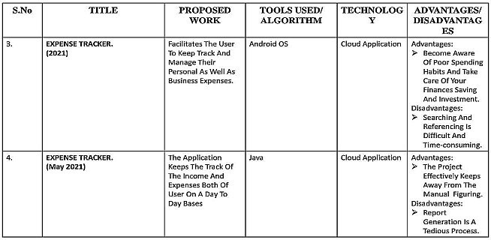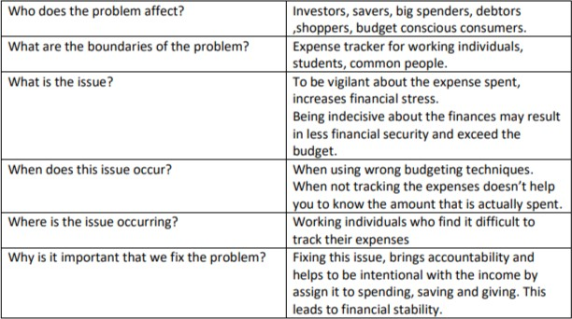

* 1. **PROBLEM STATEMENT DEFINITION:**

Tracking the expenses throughout the month is essential because it provides insight about the way in which the money is spent and also helps to frame a better budgeting plan for the upcoming days. Thus, personal expense tracker application has made tracking and managing expenses a breeze.

* + - Abella ,who is a shopholic ,ﬁnds it hard to control her desire to shop .To stop her from overindulging in impulsive purchases, she needs to track her expenses and hold herself accountable.
    - John, who is interested to invest in stocks, ﬁnds it diﬃcult to ﬁgure out the expense that he can

spend on investing stocks. With the help of expense tracking, he can easily plan out the expenses for investing in an eﬃcient way.

* + - Akshay, is a high school student, who usually gets a limited allowance from his parents. So

tracking his expenses and good budgeting technique allows him to spend on his regular expenses as well as on himself.

* + - Udhay ,who is a novice budgeter, ﬁnds it tedious to track and manage the expenses amongst

his busy schedule . Prioritizing his expenses will help him to curtail his unnecessary expenditures.

# IDEATION AND PROPOSED SOLUTION

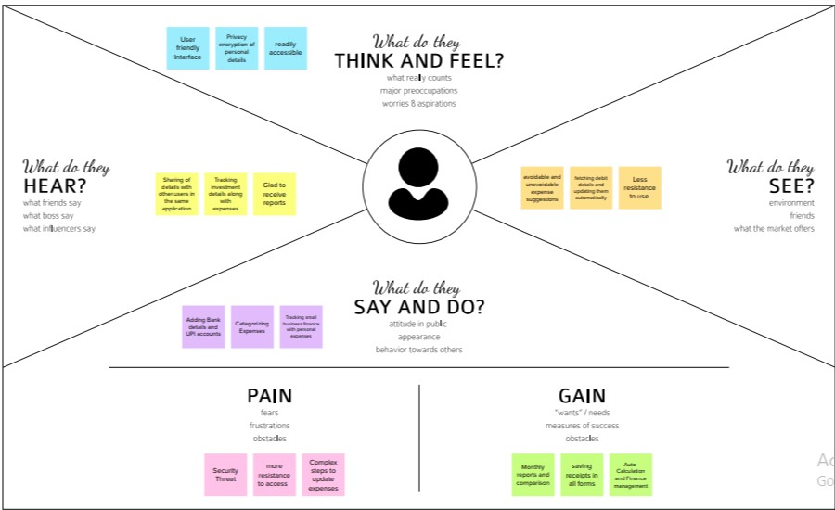

## EMPATHY MAP CANVAS:

An empathy map is a simple, easy-to-digest visual that captures knowledge about a user’s behaviours and attitudes. It is a useful tool to helps teams better understand their users. Creating an effective solution requires understanding the true problem and the person who is experiencing it. The exercise of creating the map helps participants consider things from the user’s perspective along with his or her goals and challenges.

## IDEATION AND BRAINSTORMING:

Brainstorming provides a free and open environment that encourages everyone within a team to participate in the creative thinking process that leads to problem solving. Prioritizing volume over value, out-of-the-box ideas are welcome and built upon, and all participants are encouraged to collaborate, helping each other develop a rich amount of creative solutions.Use this template in your own brainstorming sessions so your team can unleash their imagination and start shaping concepts even if you're not sitting in the same room.

### STEP1: DEFINE YOUR PROBLEM STATEMENT

What problem are you trying to solve? Frame your problem as a How Might We statement.

This will be the focus of your brainstorm

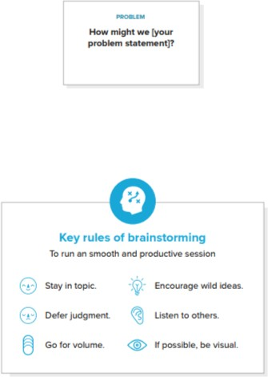

### STEP 2: BRAINSTORMING

Write down any ideas that come to mind that address your problem statement

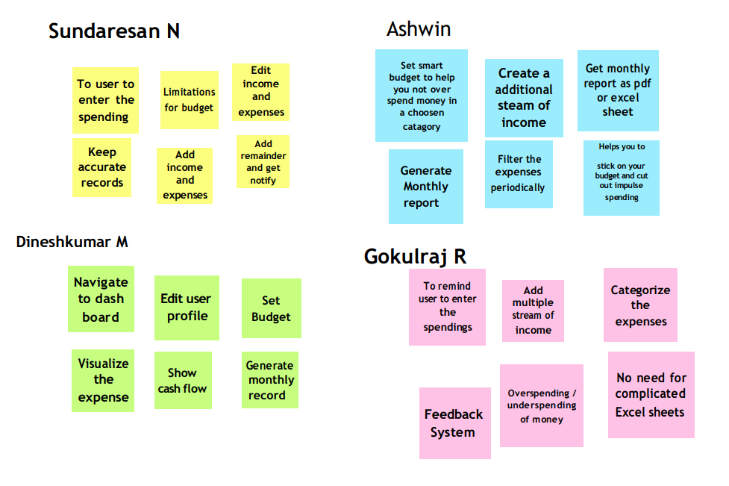

### STEP 3: GROUP IDEAS

Take turns sharing your ideas while clustering similar or related notes as you go. In the last 10 minutes, give each cluster a sentence-like label. If a cluster is bigger than six sticky notes, try and see if you and break it up into smaller sub-groups.

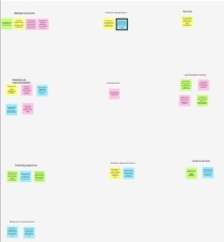

### STEP 4: IDEA PRIORITIZATION

Prioritize Your team should all be on the same page about what's important moving forward. Place your ideas on this grid to determine which ideas are important and which are feasible.

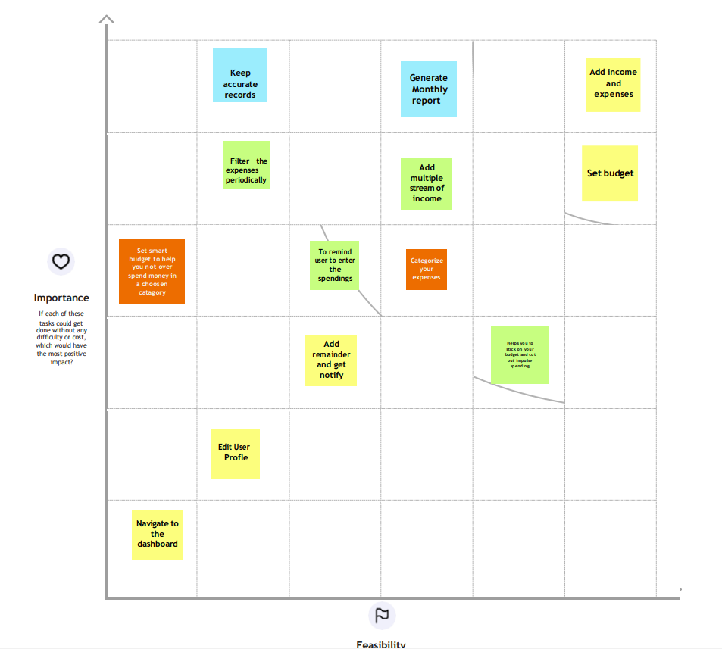

## PROPOSED SOLUTION:

Project team shall ﬁll the following information in proposed solution template.

|  |  |  |
| --- | --- | --- |
| **S.No.** | **Parameter** | **Description** |
| 1. | Problem Statement (Problem to be solved) | The problem to be solved is that people ﬁnd it hard to keep track of the monthly expenses and also to prevent compulsive spending. |
| 2. | Idea / Solution description | Personal expense tracker application allows the user to add the income and expenses. Accordingly, the expense wallet gets updated. An analysis of the expenditure in graphical form could be obtained.  The user also gets notiﬁed if the monthly limit for  the budget is exceeded. |

|  |  |  |
| --- | --- | --- |
| 3. | Novelty / Uniqueness | The personal expense tracker application helps the user not only in budgeting and accounting; it also provides the insights about money management through the analysis. The user also gets notiﬁed if the monthly limit is exceeded. |
| 4. | Social Impact / Customer Satisfaction | The application allows the user to budget, account and get insights on money management. So the users get satisﬁed with eﬃcient planning. |
| 5. | Business Model (Revenue Model) | The application can have free and premium version where the user can upgrade to premium version to access additional features. Also, the premium version may be advertisement free. |
| 6. | Scalability of the Solution | This application is not only applicable for personal use but also can be extended to business  organisations. |

* 1. **PROBLEM SOLUTION FIT:**

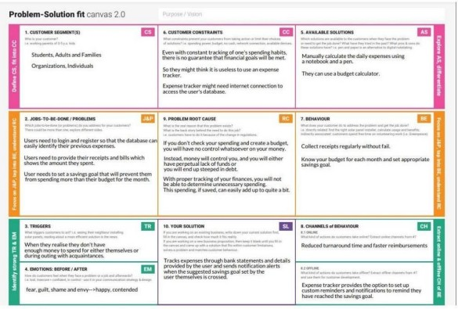

# REQUIREMENT ANALYSIS

## FUNCTIONAL REQUIREMENT :

Following are the functional requirements of the proposed solution.

## NON FUNCTIONAL REQUIREMENTS :

Following are the non functional requirements of the proposed solution.

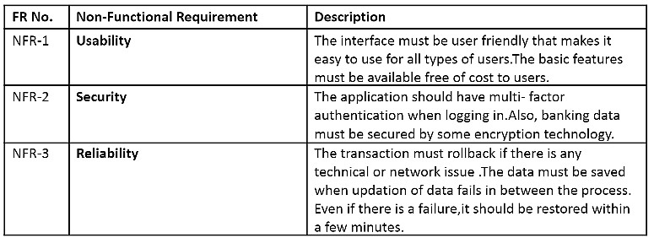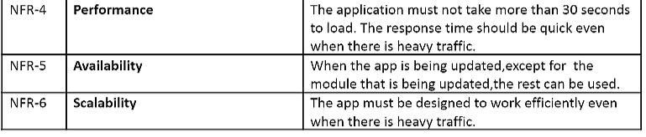

# PROJECT DESIGN

## DATA FLOW DIAGRAMS

A Data Flow Diagram (DFD) is a traditional visual representation of the information ﬂows within a system. A neat and clear DFD can depict the right amount of the system requirement graphically. It shows how data enter and leaves the system, what changes the information, and where data is stored.

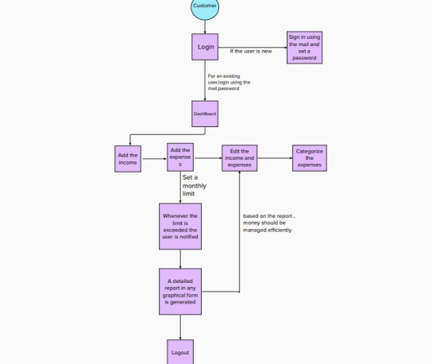

## SOLUTION AND TECHNICAL ARCHITECTURE: SOLUTION ARCHITECTURE:

**TECHNICAL ARCHITECTURE :**

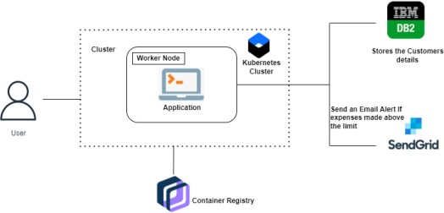

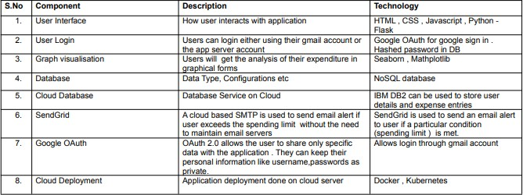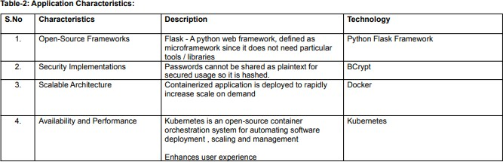**Table-1: Components and technology :**

## USER STORIES:

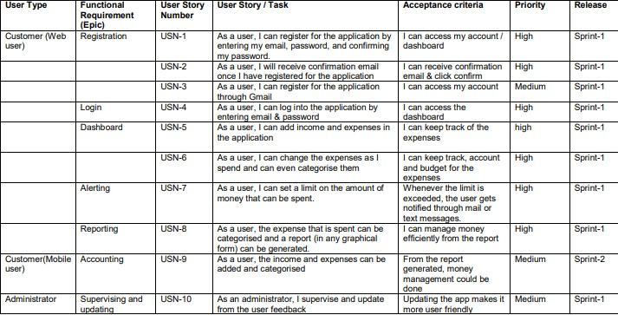Use the below template to list all the user stories for the products.

# PROJECT PLANNING AND SCHEDULING

## SPRINT PLANNING AND ESTIMATION:

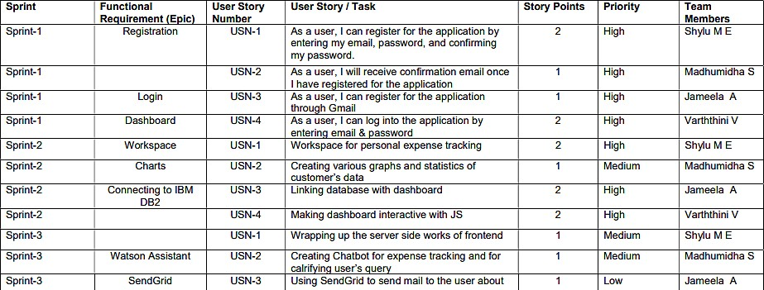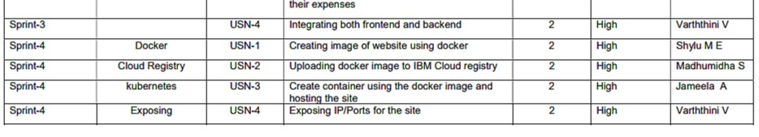

* 1. **SPRINT DELIVERY SCHEDULE :**

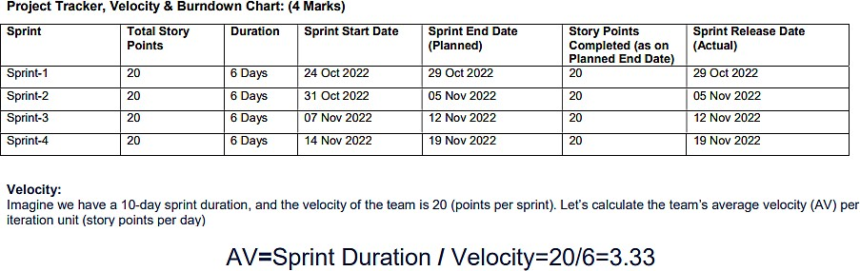

* 1. **REPORTS FROM JIRA :**

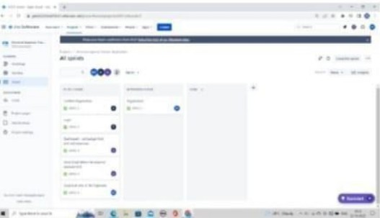

# CODING & SOLUTIONING

## FEATURE - 1

Data visualization on methods for expenditure are added. The pie chart is a pictorial representation of data that makes it possible to visualize the relationships between the parts and the whole of a variable .The pie chart have been used to represent the monthly expenses.

The recommended use for pie charts is two- dimensional, as three-dimensional use can be confusing.The dimensions form sectors of the measurement values.They can have one or two sizes and up to two measures.

The ﬁrst dimension is used to deﬁne the angle of each sector that makes up the chart and the second dimension optionally determines the radius of each sector. Additionally, these plots are useful for comparing data over a ﬁxed period since they do not show changes over time.

Therefore, their use should be considered if:

* + 1. You are looking to categorize and compare a set of data.
    2. You only have positive values.
    3. You have less than seven categories since a larger number can make it diﬃcult to perceive each segment.

## CODE:

#DISPLAY---graph

@app.route("/display") def display():

print(session["username"],session['id'])

param = "SELECT * FROM Expense WHERE userid = " + str(session['id']) + " ORDER BY date DESC" res = ibm_db.exec_immediate(ibm_db_conn, param)

dictionary = ibm_db.fetch_assoc(res) expense = []

while dictionary != False: temp = []

# temp.append(dictionary["ID"]) temp.append(dictionary["USERID"]) temp.append(dictionary["DATE"]) temp.append(dictionary["EXPENSENAME"]) temp.append(dictionary["AMOUNT"]) temp.append(dictionary["PAYMODE"]) temp.append(dictionary["CATEGORY"]) expense.append(temp)

print(temp)

dictionary = ibm_db.fetch_assoc(res)

return render_template('display.html' ,expense = expense) #delete---the--data

@app.route('/delete/<string:id>', methods = ['POST', 'GET' ]) def delete(id):

param = "DELETE FROM Expense WHERE userid = " + id res = ibm_db.exec_immediate(ibm_db_conn, param)

print('deleted successfully') return redirect("/display")

#UPDATE---DATA

@app.route('/edit/<id>', methods = ['POST', 'GET' ]) def edit(id):

param = "SELECT * FROM Expense WHERE userid = " + id res = ibm_db.exec_immediate(ibm_db_conn, param) dictionary = ibm_db.fetch_assoc(res)

row = []

while dictionary != False:

temp = []

# temp.append(dictionary["ID"]) temp.append(dictionary["USERID"]) temp.append(dictionary["DATE"]) temp.append(dictionary["EXPENSENAME"]) temp.append(dictionary["AMOUNT"]) temp.append(dictionary["PAYMODE"]) temp.append(dictionary["CATEGORY"]) row.append(temp)

print(temp)

dictionary = ibm_db.fetch_assoc(res)

print(row[0])

return render_template('edit.html', expenses = row[0])

## FEATURE - 2

Email notiﬁcations will be sent to the users once they cross the expenditure limit through send grid mail system. Most notiﬁcations are transactional, meaning a recipient’s action or account activity triggers them. But some notiﬁcations are marketing related, encouraging the recipient to take a speciﬁc action.

Ecommerce product notiﬁcations inform recipients about new products or discounts. Plus, unlike general marketing emails, these are highly personalized and focus on a single product. For example, if a customer views an item on your website and that item goes on sale, you can send the customer a notiﬁcation to let them know this is the best time to buy.

Users can also opt into receiving notiﬁcations when an out-of-stock item is back in stock. Notiﬁcation emails tend to perform well because the content is highly relevant to the recipient.

But the only way for the recipient to know this is if you state the content clearly in the subject line. For example, the subject line “New Sign-in to Your Account” gets straight to the point, letting the user know why you sent this notiﬁcation.

## CODE:

# email part

param = "SELECT * FROM Expense WHERE MONTH(date) = MONTH(current timestamp) AND YEAR(date)

= YEAR(current timestamp) ORDER BY date DESC"

res = ibm_db.exec_immediate(ibm_db_conn, param) dictionary = ibm_db.fetch_assoc(res)

expense = []

while dictionary != False: temp = []

# temp.append(dictionary["ID"]) temp.append(dictionary["USERID"]) temp.append(dictionary["DATE"]) temp.append(dictionary["EXPENSENAME"]) temp.append(dictionary["AMOUNT"]) temp.append(dictionary["PAYMODE"]) temp.append(dictionary["CATEGORY"]) expense.append(temp)

print(temp)

dictionary = ibm_db.fetch_assoc(res)

total=0

for x in expense: total += int(x[3])

param = "SELECT userid, limit FROM limit WHERE userid = " + str(session['id']) res = ibm_db.exec_immediate(ibm_db_conn, param)

dictionary = ibm_db.fetch_assoc(res) row = []

s = 0

while dictionary != False: temp = []

temp.append(dictionary["LIMIT"]) row.append(temp)

dictionary = ibm_db.fetch_assoc(res) s = temp[len(temp)-1]

if total > int(s):

msg = "Hello " + session['username'] + " , " + "you have crossed the monthly limit of Rs. " + str(s) + "/- !!!"

+ "\n" + "Thank you, " + "\n" + "Team Personal Expense Tracker." sendmail(msg,session['email'])

## DATABASE SCHEMA TABLES :

1. ADMIN

id INT NOT NULL GENERATED ALWAYS AS IDENTITY, username VARCHAR(32) NOT NULL,

email VARCHAR(32) NOT NULL,

password VARCHAR(32) NOT NULL

1. EXPENSE

id INT NOT NULL GENERATED ALWAYS AS IDENTITY, userid INT NOT NULL, date TIMESTAMP(12) NOT NULL,

expensename VARCHAR(32) NOT NULL, amount VARCHAR(32) NOT NULL, paymode VARCHAR(32) NOT NULL,

category VARCHAR(32) NOT NULL

1. LIMIT

id INT NOT NULL GENERATED ALWAYS AS IDENTITY, userid VARCHAR(32) NOT NULL,

limit VARCHAR(32) NOT NULL

# TESTING

## TEST CASES

|  |  |  |  |
| --- | --- | --- | --- |
| **TEST CASE ID** | **PURPOSE** | **TESTCASES** | **RESULT** |
| **TC1** | Authentication | Password with length  less than 4 characters | Password cannot be  less than 4 characters |
| **TC2** | Authentication | User Name with length  less than 2 characters | User name cannot be  less than 2 characters |
| **TC3** | Authentication | Valid user name with  minimum 2 characters | User name accepted |
| **TC4** | Authentication | User name is blank | User name cannot be  empty |
| **TC5** | Authentication | password ﬁeld is  blank | Password cannot be  empty |
| **TC6** | Authentication | Minimum 4 characters  valid password | Password accepted |
| **TC7** | Authentication | Password and conﬁrm password did not  match | Please enter same password |
| **TC8** | Authentication | Conﬁrm password  ﬁeld is blank | Please enter same  password |

* 1. **USER ACCEPTANCE TESTING**

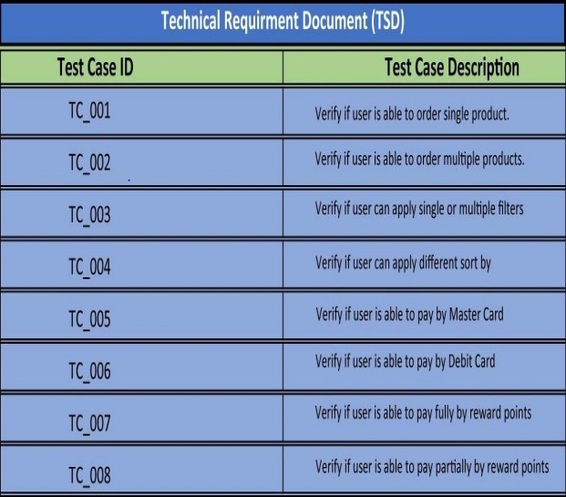

# RESULTS

## 9.1 PERFORMANCE METRICS

* Tracking income and expenses: Monitoring the income and tracking all expenditures (through bank accounts, mobile wallets, and credit & debit cards).
* Transaction Receipts: Capture and organize your payment receipts to keep track of your expenditure.
* Payments & Invoices: Accept and pay from credit cards, debit cards, net banking, mobile wallets, and bank transfers, and track the status of your invoices and bills in the mobile app itself. Also, the tracking app sendsremindersfor payments and automatically matches the payments with invoices.
* Reports: The expense tracking app generates and sends reports to give a detailed insight about proﬁts, losses, budgets, income, balance sheets, etc.,
* E-commerce integration: Integrate your expense tracking app with your eCommerce store and track your sales through payments received via multiple payment methods.
* Access control: Increase your team productivity by providing access control to particular users through custom permissions.
* Vendors and Contractors: Manage and track all the payments to the vendors and contractors added to the mobile app.
* Organizing Taxes: Import your documents to the expense tracking app, and it will streamline your income and expenses under the appropriate tax categories.
* Track Projects: Determine project proﬁtability by tracking labor costs, payroll, expenses, etc., of your ongoing project.
* In-depth insights and analytics: Provides in-built tools to generate reports with easy-to- understand visuals and graphics to gain insights about the performance of your business.
* Recurrent Expenses: Rely on your budgeting app to track, streamline, and automate all the recurrent expenses and remind you

# ADVANTAGES & DISADVANTAGES

1. Achieve your business goals with a tailored mobile app that perfectly ﬁts your business.
2. Scale-up at the pace your business is growing.
3. Deliver an outstanding customer experience through additional control over the app.
4. Control the security of your business and customer data
5. Open direct marketing channels with no extra costs with methods such as push notiﬁcations.
6. Boost the productivity of all the processes within the organization.
7. Increase eﬃciency and customer satisfaction with an app aligned to their needs.
8. Seamlessly integrate with existing infrastructure.
9. Ability to provide valuable insights.
10. Optimize sales processes to generate more revenue through enhanced data collection

# CONCLUSION

From this project, we are able to manage and keep tracking the daily expenses as well as income. While making this project, we gained a lot of experience of working as a team. We discovered various predicted and unpredicted problems and we enjoyed a lot solving them as a team. We adopted things like video tutorials, text tutorials, internet and learning materials to make our project complete.

# FUTURE

The project assists well to record the income and expenses in general. However, this project has some limitations:

* This application does not provide higher decision capability.
* The application is unable to maintain the backup of data once it is uninstalled.

To further enhance the capability of this application, we recommend the following features to be incorporated into the system:

* Mobile apps
* Multiple language interface.
* Provide backup and recovery of data.
* Better user interface for user.

# APPENDIX

## SOURCE CODE GITHUB LINK :

https://github.com/IBM-EPBL/IBM-Project-16212-1659609643